

Vehicle Count Prediction From Sensor Data

Design & developed by

M. Srithik 2211CS050064

GUIDED BY

Mr.M.Ravi kumar
(Assistant Professor)

Department of Computer Science & Engineering (INTERNET OF THINGS)
IIYR-IISEM
Malla Reddy University, Hyderabad 2022-2026



CERTIFICATE

This is to certify that this is the bonafide record of the application development entitled “VEHICLE COUNT PREDICTION FROM SENSOR DATA”, submitted by M. Srithik(2211CS050064), B. Tech III year I semester, Department of CSE (IoT) during the year 2023-24. The results embodied in this report have not been submitted to any other university or institute for the award of any degree or diploma.

Internal Guide Head of the department
Mr.M. Ravikumar Dr.G.Anand Kumar (Assistant Professor) CSE(IoT)

External Examiner

DECLARATION

We hereby declare that the project report entitled “VEHICLE COUNT PREDICTION FROM SENSOR DATA”, has been carried out by us. This work has been submitted to the Department of Computer Science and Engineering (Internet of Things), Malla Reddy University, Hyderabad in partial fulfillment of the requirements for the award of degree of Bachelor of Technology. We further declare that this project work has not been submitted in full or in part for the award of any other degree in any other educational institutions.

Place:
Date:

M. Srithik 2211CS050064

ACKNOWLEDGEMENT

We extend our sincere gratitude to all those who have contributed to the completion of this project report. Firstly, we would like to extend our gratitude to Dr. V. S. K Reddy, Vice-Chancellor, for his visionary leadership and unwavering commitment to academic excellence.
We would also like to express our deepest appreciation to our project guide Dr. B.Nageshwar Rao Assistant Professor, Dept. of Cyber Security & IoT, whose invaluable guidance, insightful feedback, and unwavering support have been instrumental throughout this project for successful outcomes.
We are also grateful to Dr. G. Anand Kumar, Head of the Department of Cyber Security & IoT, for providing us with the necessary resources and facilities to carry out this project.
We extend our gratitude to our PRC-convenor, Dr. G. Latha, for giving valuable inputs and timely guidelines to improve the quality of our project through a critical review process. We thank our project coordinator, Dr. G. Latha, for his timely support.
We would like to thank Dr. Kasa Ravindra, Dean, School of Engineering, for his encouragement and support throughout my academic pursuit.
My heartfelt thanks also go to Dr. Harikrishna Kamatham, Associate Dean School of Engineering for his guidance and encouragement.
We are deeply indebted to all of them for their support, encouragement, and guidance, without which this project would not have been possible.

M. Srithik 2211CS050064

ABSTRACT

Sensors which are placed in road junctions collect the data of no of vehicles at different junctions and gives data to the transport manager. Now our task is to predict the total no of vehicles based on sensor data. Accurate vehicle count prediction is critical for traffic management, urban planning, and reducing congestion on road networks. This paper presents a machine learning-based approach to predict vehicle counts using sensor data collected from roadways. The study leverages data from various types of traffic sensors, including loop detectors, infrared sensors, and cameras, to develop predictive models capable of estimating the number of vehicles in a given time frame.
The results demonstrate the efficacy of machine learning models in predicting vehicle counts from sensor data, highlighting their potential to enhance traffic flow management and reduce congestion. The proposed application offers a scalable and adaptable solution for modern cities facing increasing traffic demands.
TABLE OF CONTENTS

Contents Page No

1. Introduction 8-13
1.1 Problem Definition & Description 8-10
1.2 Objective of the Project 10-12
1.3 Scope of the Project 12-13
2. System Analysis 14-23
2.1 Existing System 14-17
2.1.1 Background & Literature Survey 14-15
2.1.2 Limitations of Existing System 17-19
2.2 Proposed System 19
2.2.1 Advantages of Proposed System 19
2.3 Software & Hardware Requirements 19-22
2.3.1 Software Requirements 20
2.4 Feasibility Study 20-23
2.4.1 Technical Feasibility 21
2.4.2 Robustness & Reliability 22
2.4.3 Economic Feasibility 23
3. Architectural Design 24-38
3.1 Modules Design 24-29
3.1.1 Data Pre-processing 24-26
3.1.2 Feature Extraction & Selection 26-27
3.1.3 Number of Modules as per analysis 28-29
3.2 Project Architecture 30-38
3.2.1 Complete architecture 31-32
3.2.2 Data Flow & Process Flow Diagrams 32-33
3.2.3 Class Diagram 34-36
3.2.4 Use case Diagram 36-37
3.2.5 Sequence Diagram 37-38
4. Implementation 39-49
4.1 Coding Blocks 39-41
4.2 Sample Code 42-43
4.3 Execution Flow 44-47
4.4 Testing 47-49

5. Results 50

6.Conclusion and future scope 51-53

REFERENCES 53-54

PAPER PUBLICATION 55-57

POSTER 58
CHAPTER-1

1.INTRODUCTION

  - Problem Definition & Description

With the rapid increase in urbanization and vehicle ownership, traffic management has become a critical issue for cities worldwide. Efficiently managing traffic flow is essential to reduce congestion, minimize travel times, and improve road safety. Accurate vehicle count prediction is a crucial component of traffic management systems, enabling authorities to plan and adjust traffic signals, manage toll systems, and develop strategies to alleviate peak-hour congestion. Traditional methods of vehicle counting, such as manual counting or video-based counting, are either labor-intensive or limited by environmental factors like lighting and weather conditions.

Sensor-based vehicle count prediction leverages data from sensors, such as inductive loop sensors, infrared sensors, and radar, which are widely deployed at key points along roadways. These sensors provide continuous, real-time data that can be used to monitor and predict traffic volumes effectively. However, analyzing this data to accurately predict vehicle counts is challenging due to variability in traffic patterns, sensor noise, and the influence of external factors such as weather, time of day, and special events.

The objective of this project is to develop a predictive model capable of analyzing sensor data to forecast vehicle counts accurately. This involves using machine learning and statistical techniques to process and interpret large volumes of sensor data. By building a robust predictive model, we aim to enhance traffic management capabilities, enabling timely and data-driven decisions that can help reduce congestion and improve traffic flow in urban areas.
The problem of vehicle count prediction from sensor data is central to effective traffic management, urban planning, and reducing congestion on road networks. As urban populations grow, so does the demand on transportation infrastructure, leading to frequent bottlenecks, increased travel times, and air pollution. Traffic management systems are increasingly relying on real-time data from various types of sensors deployed at key road junctions to monitor and manage traffic flow dynamically. However, to maximize the benefits of such data, accurate predictions of vehicle counts are needed to inform decisions, predict congestion, and plan for future demands on road networks.

In this study, we focus on developing a machine learning-based approach for predicting vehicle counts at road junctions using data collected from multiple types of sensors, including loop detectors, infrared sensors, and cameras. These sensors provide a rich dataset capturing the frequency and density of vehicles over time, often in near real-time. Loop detectors, embedded in the pavement, detect the presence and count of vehicles passing over them, while infrared sensors can detect vehicle presence without direct contact, and camera-based systems offer visual data that can be processed for vehicle count estimation. Aggregating data from these sources provides a comprehensive view of traffic patterns, making it possible to create robust predictive models capable of estimating vehicle counts across different time frames.

The goal of this research is to use sensor data to build predictive models that forecast vehicle counts with high accuracy. This prediction process involves multiple steps, including data preprocessing, feature engineering, model training, and evaluation, all of which contribute to building a model that can generalize well across various traffic conditions. Accurate predictions will allow traffic managers to anticipate congestion, optimize traffic light timings, and make data-driven decisions for route planning and road infrastructure development.

  - Objective of the Project

The primary objective of this project is to develop a predictive model that accurately forecasts vehicle counts using real-time sensor data from road networks. By leveraging data from various sensors—such as inductive loops, infrared, and radar sensors—this model aims to provide a reliable,
continuous assessment of traffic volumes. Accurate vehicle count predictions can enable traffic authorities to make proactive, data-driven decisions that help mitigate congestion, improve traffic flow, and reduce environmental impacts from idling vehicles.

The objective of this project is to develop an accurate and efficient system for predicting vehicle counts based on sensor data. By leveraging real-time data collected from various traffic sensors, such as loop detectors, cameras, or LIDAR, the system aims to provide precise vehicle counts at specific locations and times. This prediction model is valuable for traffic management, enabling authorities to monitor congestion levels, optimize traffic light timings, and improve road infrastructure planning. Ultimately, the project strives to enhance urban mobility, reduce traffic-related delays, and contribute to safer and more efficient road networks.

The objective of this project is to develop an accurate, efficient, and scalable system for predicting vehicle counts using sensor data collected from road junctions. Accurate predictions of vehicle counts are essential for effective traffic management, urban planning, and congestion control, as they provide key insights into road network usage and patterns of traffic flow. With a reliable predictive model, transport managers can anticipate peak traffic periods, manage signal timings more effectively, and deploy resources proactively to prevent or alleviate congestion. By understanding vehicle counts in real time, city planners and traffic management authorities can optimize infrastructure, make data-driven policy decisions, and improve the overall efficiency and safety of transportation networks.

This project focuses on leveraging data from various traffic sensors, including loop detectors, infrared sensors, and cameras, placed strategically across road junctions. The diversity of sensor types enables a more comprehensive understanding of traffic dynamics and enhances the model’s accuracy in varying road and weather conditions. By integrating data from these multiple sources, we aim to develop a robust machine learning model capable of predicting vehicle counts across different time intervals, accounting for factors such as location, time of day, and historical trends. This data-driven approach provides a foundational step toward a smarter traffic management system, contributing to more sustainable urban environments by reducing emissions, lowering commute times, and enhancing the quality of life for city residents.

Ultimately, the project’s goal is to build a predictive framework that can adapt to changing traffic patterns, supporting real-time decision-making for transport managers and urban planners. By implementing a system that dynamically learns from historical and real-time data, we can ensure that the model’s predictions remain accurate and relevant, even as traffic conditions evolve.

  - Scope of the Project

Data Collection and Preprocessing: Gather and preprocess data from various traffic sensors (e.g., inductive loops, infrared sensors, radar) installed along roadways. Address potential data issues, such as noise, missing values, and sensor calibration, to ensure a clean, high-quality dataset for model training and testing.
Exploratory Data Analysis (EDA): Conduct an in-depth analysis of the collected data to identify patterns, trends, and potential correlations between sensor readings and vehicle counts.Identify external factors that impact traffic flow, such as peak hours, weekends, holidays, and weather patterns.
Model Development: Develop and compare various machine learning models (e.g., time-series models, regression models, neural networks) to predict vehicle counts.
Evaluation Metrics:Define key performance metrics (e.g., Mean Absolute Error (MAE), Mean Squared Error (MSE), Root Mean Squared Error (RMSE)) to evaluate the model’s prediction accuracy.
Deployment and Integration:Integrate the model into a traffic management system or develop a standalone application that can predict vehicle counts in real-time based on incoming sensor data.
Visualization and Reporting
- Develop a dashboard or reporting tools for visualizing vehicle counts, trends, and predictions.
- Include alerts or notifications for significant deviations from expected counts, useful for traffic management or incident detection.
Documentation and User Training
- Provide clear documentation, covering data processing, model architecture, and usage instructions.
- Train end users or stakeholders on how to use the prediction system effectively.
Future Scope and Scalability
- Plan for scaling the system to include more sensors, roads, or types of vehicles in the future.
- Outline opportunities to enhance the system with additional features like vehicle classification, congestion prediction, or route optimization.

Testing and Validation:Conduct extensive testing in real-world scenarios
to validate the model’s predictions and identify any issues or biases in
varying traffic conditions.

.

CHAPTER-2

2. SYSTEM ANALYSIS

2.1 Existing System
2.1.1 Background & Literature Survey
In recent years, urban transportation networks have been growing more congested, creating a demand for efficient and real-time vehicle counting systems to optimize traffic flow and reduce congestion. Traditional traffic monitoring methods, such as manual counting or video-based observation, are often labor-intensive, expensive, and prone to inaccuracies due to environmental factors. These limitations have prompted a shift toward sensor-based vehicle counting systems that leverage various types of sensors like infrared, ultrasonic, inductive loop, and acoustic sensors to automate the vehicle counting process.

The existing systems in vehicle count prediction predominantly rely on data collected from such sensors. For instance, inductive loop sensors are widely used for traffic monitoring due to their reliability and durability, yet they require significant road surface modifications and maintenance, which can be costly and disruptive. Similarly, infrared and ultrasonic sensors offer non-intrusive alternatives but may face challenges in accuracy due to adverse weather conditions or obstructions. The recent development of Internet of Things (IoT) networks and machine learning algorithms has enabled the integration of multiple sensors, which together provide more comprehensive and precise data.

The existing systems in vehicle count prediction predominantly rely on data collected from such sensors. For instance, inductive loop sensors are widely used for traffic monitoring due to their reliability and durability, yet they require significant road surface modifications and maintenance, which can be costly and disruptive. Similarly, infrared and ultrasonic sensors offer non-intrusive
alternatives but may face challenges in accuracy due to adverse weather conditions or obstructions. The recent development of Internet of Things (IoT) networks and machine learning algorithms has enabled the integration of multiple sensors, which together provide more comprehensive and precise data.

The literature on vehicle count prediction highlights numerous methodologies. Machine learning and deep learning models such as regression models, decision trees, and neural networks have shown promise in accurately predicting vehicle counts from sensor data. Many studies emphasize the use of data fusion techniques, where multiple sensors are used to collect complementary data, enhancing the accuracy and robustness of vehicle counting. Furthermore, research on temporal and spatial analysis of sensor data has contributed to more accurate traffic predictions by accounting for peak times and traffic patterns.

In summary, while traditional traffic counting methods face limitations, the evolution of sensor-based systems and advancements in data processing and machine learning have created more accurate and scalable solutions for vehicle count prediction. Future research continues to focus on improving sensor accuracy, reducing system costs, and enhancing real-time processing capabilities.

Vehicle count prediction is essential for traffic management, urban planning, and mitigating congestion on road networks. With the advancement of sensor technologies, various types of traffic sensors, including inductive loop detectors, infrared sensors, and camera-based systems, are deployed to monitor traffic flows at key points, especially intersections and road junctions. These sensors generate substantial data in real time, which can be utilized to estimate vehicle counts and support proactive traffic management. Traditional methods for vehicle counting, such as manual counting or simple rule-based systems, have proven insufficient in handling the increasing complexity of urban traffic, especially given the non-linear patterns that characterize vehicle flow in dense networks.

In recent years, machine learning and data-driven methods have become pivotal in transforming raw sensor data into accurate vehicle count predictions. Studies have explored various approaches, from linear regression models to complex deep learning architectures, for capturing temporal and spatial dependencies in traffic data. For instance, time-series forecasting methods, such as ARIMA (Auto-Regressive Integrated Moving Average), have been widely applied in early traffic prediction research due to their simplicity and interpretability, but they often struggle to capture non-linear relationships inherent in traffic flow. Machine learning methods, such as decision trees, random forests, and support vector machines, have demonstrated greater accuracy by handling non-linearity and allowing feature engineering to incorporate additional information like weather, day of the week, and historical patterns.

With the advent of deep learning, neural networks, particularly recurrent neural networks (RNNs) and their variants like long short-term memory (LSTM) networks, have shown promise in vehicle count prediction due to their ability to retain information over sequences, making them effective for temporal prediction tasks. Convolutional neural networks (CNNs) have also been used with image data from camera sensors to directly analyze vehicle presence, bypassing the need for manual feature extraction. More recently, hybrid models that combine multiple approaches, such as combining LSTMs with convolutional layers, have been developed to leverage both spatial and temporal aspects of the data.

In addition to model architecture advancements, feature engineering has played a critical role in enhancing prediction accuracy. Features such as historical traffic data, time of day, weather conditions, and even socio-economic factors have been integrated into predictive models to capture broader patterns influencing traffic flow. Integrating various data sources has led to more robust and generalizable models capable of adapting to different urban contexts and traffic dynamics. The literature highlights that a robust vehicle count prediction model can lead to better traffic signal control, route planning, and congestion management, ultimately enhancing the efficiency of urban transportation networks. However, challenges remain, including managing sensor data quality, handling missing data, and ensuring the scalability of models in large urban areas. This body of work serves as a foundation for developing machine learning-driven vehicle count prediction systems that can address these challenges and support intelligent transportation systems.

2.1.2 Limitations of Existing System

Environmental Sensitivity: Many sensors, such as infrared and ultrasonic, are sensitive to environmental factors like rain, fog, extreme temperatures, and lighting conditions.
High Installation and Maintenance Costs: Traditional sensors like inductive loops require embedding in the road surface, which involves extensive installation work and road closures

Limited Coverage and Field of View: Sensors such as infrared and acoustic types often have a limited field of view, which can cause issues in counting vehicles across multiple lanes or during peak traffic.
Data Processing and Real-Time Constraints: Processing sensor data in real-time requires significant computational resources. For many existing systems, the infrastructure or algorithms may be too slow to provide real-time updates, limiting their effectiveness for dynamic traffic management applications.
Dependence on Infrastructure: Some sensor-based systems rely on an extensive network of devices, which may not be feasible in rural or developing regions with limited infrastructure.
Calibration and Drift Over Time: Sensors require regular calibration to maintain accuracy, as their readings may drift over time. Without consistent calibration, data quality may degrade, leading to inaccurate predictions and necessitating frequent maintenance.
Limited Adaptability to Changing Traffic Patterns: Many systems are designed based on historical data, which may not adapt well to sudden shifts in traffic patterns, such as those caused by special events, road closures, or seasonal changes. This limits the robustness of prediction models in real-world, variable environments.
Privacy and Data Security Concerns: Advanced systems with cameras or IoT-enabled sensors may raise privacy concerns, as they capture detailed vehicle and traffic data. Ensuring the security and privacy of data in a connected infrastructure is essential but can be challenging, especially with limited cybersecurity measures.

2.2 Proposed System

A proposed system for vehicle count prediction from sensor data involves the use of real-time data from traffic sensors installed on roads. The system gathers data such as vehicle speed, direction, and proximity, which is then processed to determine the number of vehicles passing through a specific area. Using advanced data analysis methods like machine learning or deep learning algorithms, the system can detect patterns and predict vehicle counts accurately. The data is first pre-processed to remove noise, then fed into a model trained on historical traffic data. This model evaluates factors like time of day, traffic trends, and environmental conditions to improve prediction accuracy. The output is a continuous, real-time vehicle count, which can be integrated with traffic management systems to optimize traffic flow, reduce congestion, and inform city planning decisions. This automated system enables efficient and reliable traffic monitoring, providing a scalable solution for urban traffic management.
This paper proposes a machine learning-based system to predict vehicle counts from sensor data collected at road junctions, which is crucial for effective traffic management, urban planning, and congestion reduction. Sensors such as loop detectors, infrared sensors, and cameras, positioned at various intersections, gather vehicle data, which is then relayed to a transport manager. Our goal is to accurately estimate the total vehicle count using this data. By employing predictive models, the system can effectively analyze sensor data and estimate vehicle numbers over specified time frames. Accurate vehicle count predictions from such a system can support informed decision-making in traffic control and infrastructure planning, ultimately leading to more efficient and less congested urban road networks.

The proposed system for vehicle count prediction from sensor data leverages an integrated machine learning approach to accurately estimate traffic volume at various road junctions. The system consists of sensors, including loop detectors, infrared sensors, and cameras, strategically positioned at key junctions to collect real-time data on vehicle presence and flow. This raw sensor data undergoes a preprocessing phase to handle issues like missing values, outliers, and inconsistent formats. Next, data from different sensors is aggregated into a unified dataset categorized by location, time, and date, enabling comprehensive analysis of traffic patterns. Feature engineering is applied to extract informative variables, such as average vehicle count by time of day, day of the week, and other contextual elements like weather conditions.

The system then splits this prepared dataset into training, validation, and test subsets to ensure robust model training and evaluation. For model selection, the system tests various algorithms suited to time-series prediction and regression tasks, such as linear regression, decision trees, random forests, or neural networks, and selects the one that best fits the data characteristics and desired prediction accuracy. Training is performed on the model to learn the relationships between input features and vehicle counts, aiming to minimize the prediction error. After training, the model’s performance is evaluated using validation data, employing metrics like Mean Absolute Error (MAE) or Root Mean Squared Error (RMSE) to measure prediction accuracy. Optimization techniques, such as hyperparameter tuning, are applied to refine the model for enhanced accuracy.

The optimized model is then used to predict vehicle counts for specified time intervals at each junction based on real-time sensor data. These individual junction predictions are aggregated to estimate total vehicle counts for larger regions or cities, helping transport managers monitor traffic volume and congestion levels. Additionally, the system supports real-time data input, where predictions are updated dynamically with incoming data, and a feedback loop is established to compare predicted versus actual counts. This allows for periodic model retraining, adapting to evolving traffic patterns for long-term accuracy. Once fully optimized, the model is integrated into a traffic management system, enabling real-time, data-driven decision-making for traffic routing, signal optimization, and congestion control, ultimately contributing to improved traffic flow and reduced congestion.

2.2.1 Advantages of Proposed System
Real-Time Data Collection and Analysis: Using sensors, the system can gather data continuously, enabling real-time vehicle counting and analysis. This can be especially beneficial for traffic management and congestion monitoring.
High Accuracy and Precision: Advanced sensor-based systems can achieve a high level of accuracy in vehicle counting, reducing errors that might occur with manual counting or less sophisticated systems.
Scalability: Sensor-based vehicle counting systems can be easily scaled to cover larger areas by adding additional sensors. This is particularly useful in urban environments where traffic patterns need to be monito78red across multiple intersections or road segments.

2.3 Software & Hardware Requirements
2.3.1 Software Requirements
Operating System:
Linux (Ubuntu) for ease of development and compatibility with ML frameworks Windows is also possible but is generally less preferred for high-performance server setups
Machine Learning Libraries:
Scikit-Learn for classical ML algorithms if deep learning isn’t necessary
TensorFlow or PyTorch for model development
OpenCV for image/video processing if using visual sensors
Data Processing &Storage:
Apache Kafka or MQTT for real-time data streaming if sensors are continuously sending data.

2.4 Feasibility Study

2.4.1 Technical Feasibility
Data Collection: Gather sensor data from traffic cameras, inductive loops, radar, or other sensors. These sensors collect vehicle-related data such as speed, count, and classification.
Data Processing: Preprocess the data to filter noise, handle missing values, and standardize it for analysis.
Model Development: Use machine learning or statistical models like regression, neural networks, or time-series forecasting to predict vehicle counts based on historical sensor data. Train models on labeled datasets for improved accuracy.
Evaluation Metrics: Use metrics like Mean Absolute Error (MAE), Root Mean Squared Error (RMSE), or R-squared to evaluate model performance.
2.4.2 Robustness & Reliability

Handling Sensor Noise: Sensor data is often noisy due to environmental factors (e.g., weather, calibration issues). Robust models can filter out noise and still provide reliable predictions.

Generalization Across Scenarios: Reliable models can generalize well to different traffic conditions, sensor placements, and times of day, ensuring accuracy regardless of variations in the data.
Adaptability to Data Changes: Robust systems can adapt to changes in traffic patterns or sensor behavior over time without significant performance degradation.
Error Handling and Fault Tolerance: A reliable system identifies and mitigates errors from faulty sensors or missing data, ensuring continuity of predictions.

2.4.3 Economic Feasibility

Initial Investment: The cost of installing sensors, infrastructure, and software for data collection and processing.
Operational Costs: Ongoing expenses for maintenance, data storage, and software updates.
Scalability: The ability to scale the system across regions without disproportionate increases in costs.

CHAPTER-3
3. ARCHITECTURAL DESIGN
3.1 Modules Design
3.1.1 Data Pre-processing
Data Collection: Collect sensor data (e.g., from loop detectors, cameras, or radar sensors). The data typically includes timestamps, vehicle counts, sensor ID, vehicle type, speed, and lane information.

Data Cleaning: Handling Missing Values: Identify and handle missing or corrupted data points using imputation techniques (mean, median, interpolation) or by removing the incomplete entries.

Outlier Detection: Use statistical methods (Z-score, IQR) to identify and filter out outliers in the vehicle count or other sensor data that could distort predictions.

Data Transformation: If the data is not already in a time-series format, structure it by assigning correct timestamps and ensuring regular intervals.

Data Aggregation: Aggregate data based on time intervals (hourly, daily) or location (individual sensors or sensor zones) to simplify the modeling process.

Labeling (for Supervised Learning): If using historical data to predict future counts, label the dataset with the correct output variable (future vehicle count, traffic flow, etc.).

Data Splitting: Split the data into training and testing sets, ensuring that temporal dependencies are respected (e.g., use past data to predict future values).
Sensor Fusion (Optional): If multiple sensor types are involved (e.g., video, radar, loop detectors), combine data from different sources into a single feature set that reflects the full sensor input.

Handle Missing Values: Sensors may fail or generate incomplete data. Impute missing values using techniques like forward filling, backward filling, or interpolation. Alternatively, rows with missing critical data could be removed if the missing data is sparse.

Outlier Detection: Identify and handle outliers (e.g., unusually high or low vehicle counts that are not realistic) using statistical methods like z-scores or IQR (Interquartile Range). Outliers can be removed or capped based on domain knowledge.
Duplicate Removal: Check for and remove any duplicate records, especially if multiple sensors may report the same data point.

Timestamp Conversion: Convert timestamps into useful features such as hour of the day, day of the week, or month. These features help capture time-based patterns in traffic, like peak hours or seasonal traffic trends.
Normalization/Standardization: Normalize or standardize data, especially if combining data from different types of sensors (e.g., infrared sensors, loop detectors). Scaling helps to ensure that features with different units or magnitudes don’t bias the model.
Categorical Encoding: If categorical data is present (e.g., junction identifiers, sensor types), encode them using techniques like one-hot encoding or label encoding to make them usable for machine learning algorithms.
Data Aggregation:

Sensor Data Aggregation: Since vehicle data might be recorded by different sensors at different junctions, aggregate the data into a unified format (e.g., total vehicle count per junction, per time period). This may involve summing, averaging, or computing other statistical measures over a given time window.
Time Window Creation: Create time windows or bins (e.g., 15-minute, hourly, or daily intervals) to ensure the data aligns with a regular time frame for consistent predictions.

Temporal Features: Extract features such as the hour of the day, day of the week, month, holiday, weather conditions, or traffic signals’ status. These factors can significantly influence traffic flow.
Historical Data: Use past vehicle count data to create lag features. For example, the number of vehicles at a junction in the previous time window can be a good predictor for the current window.
Weather Data: Include external factors such as temperature, rainfall, or visibility, as these can affect traffic flow. Integrating weather data into the model helps improve prediction accuracy.

3.1.2 Feature Extraction & Selection

Raw Sensor Data Features: Use the time of day, day of the week, and potentially month to capture cyclical patterns (e.g., rush hours, weekends).Depending on the type of sensor, the raw values can indicate vehicle presence, speed, or weight.

Statistical Features: Moving Average or Exponential Moving Average: Smooth sensor data over time, which can help detect patterns related to vehicle count.Count the peaks or pulses in a given timeframe (e.g., each minute or second), as each peak may correspond to a passing vehicle.
Time-Series Derived Features: Rolling average, sum, or count of detected vehicles in the recent time window (e.g., last 5 minutes) can capture short-term traffic dynamics.Capture periodic components related to regular traffic patterns, like morning and evening rush hours.

Environmental Features: Incorporate external data like precipitation, temperature, and visibility (if available), as these can influence traffic flow.Special events or holidays can affect traffic patterns, and incorporating these as features could improve prediction accuracy.

Correlation Analysis: Identify features that are highly correlated with vehicle
count. Remove features that have high correlation with each other, as they may
be redundant.

Feature Importance Scores: Tree-Based Models (e.g., Random Forest, Gradient Boosting): These models can provide importance scores for each feature, helping identify which features contribute most to vehicle count prediction.These methods provide explainability and help highlight which features are most significant.

Wrapper Methods: Sequential Feature Selection: Use sequential feature selection techniques, like forward or backward selection, to iteratively add or remove features based on model performance.
Recursive Feature Elimination (RFE): This technique iteratively removes the the least important features based on model performance and is often used with
tree-based models.

Dimensionality Reduction: Principal Component Analysis (PCA): If there are many correlated features, PCA can reduce dimensional while preserving variance, though it can make interoperability harder. In deep learning contexts, autoencoders can reduce features to the most essential components for predictive power.
Monitoring and Reporting Module: Data Prepossessing: Clean and processor sensor data, handling missing values and normalizing or standardizing the data.
Feature Extraction: Generate the raw, statistical, time-series, and environmental features described above.
Feature Selection: Apply feature selection methods to reduce the number of features while retaining the most predictive ones.

3.1.3 Number of Modules as per analysis

Data Collection Module: Responsible for gathering data from sensors (e.g., camera feeds, LiDAR, radar, inductive loop sensors). Includes sensor calibration and data pre-processing (like filtering, de-noising, and synchronization).
Data Preprocessing and Cleaning Module: Prepares raw data for analysis by handling missing values, outliers, and data transformation. Could involve data normalization, resizing (if images are involved), and time-series aggregation.

Feature Extraction Module: Extracts useful features from raw sensor data (e.g., object detection, trajectory tracking, speed estimation). Might employ machine learning techniques, image processing, or traditional computer vision techniques depending on sensor type.

Data Fusion Module (if using multiple sensors): Combines data from multiple sensors to improve accuracy and reliability. Uses techniques like Kalman filtering, Bayesian approaches, or deep learning

Maintenance and Update Module: Ensures the system remains accurate as conditions or vehicle patterns change.
Monitors model performance over time and retrains it if necessary.

User Interface and Visualization Module:Creates visualizations or dashboards for monitoring vehicle counts and trends.
Useful for operators to interpret data easily and make data-driven decisions.

Deployment and Real-Time Monitoring Module: Validates the model performance with metrics like accuracy, precision, recall, and Mean Absolute Error (MAE).

Evaluation and Validation Module: Develop intuitive interfaces for drivers and system administrators to monitor, manage alerts, and review system performance. Ensures robustness and reliability, especially under varying conditions (e.g., weather, lighting).

3.2 Project Architecture

3.2.1 Complete Architecture

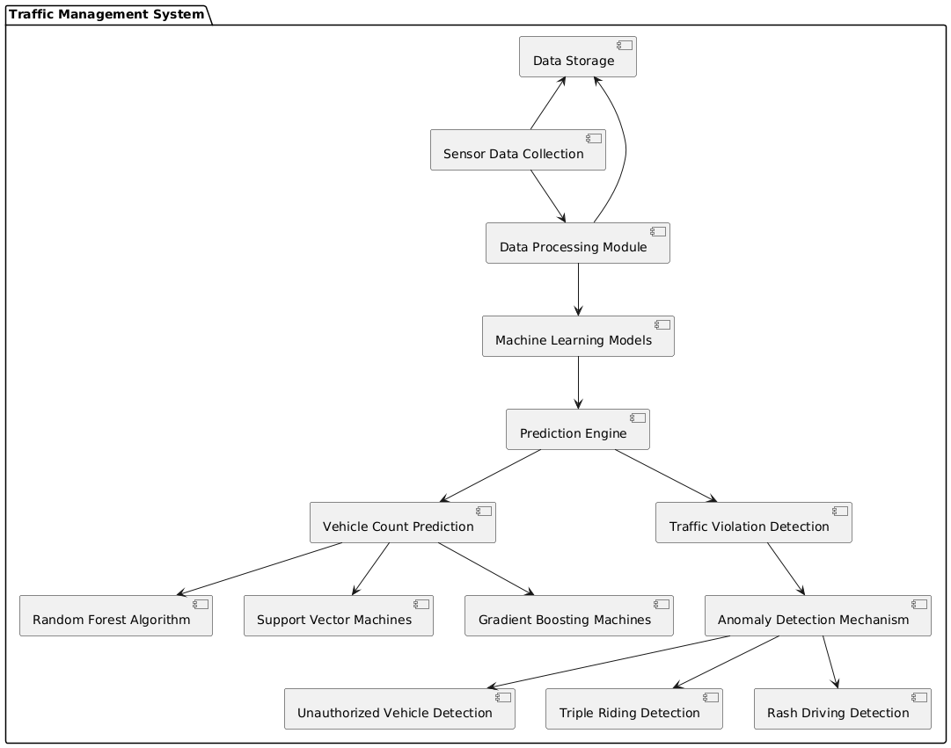

Sensors: Collect data on speed, acceleration, vehicle type, and timestamps from highways, streets, and intersections. sensors and communication channels ensure continuous monitoring.
Data Processing Module: Processes the collected data to identify patterns and prepares it for machine learning
Traffic Violation Detection: Monitors for unauthorized vehicles, triple riding, and rash driving through an anomaly detection mechanism.
Anomaly Detection Mechanism: Flags behaviors that deviate from expected patterns based on predefined thresholds.

3.2.2 Data Flow & Process Flow Diagram

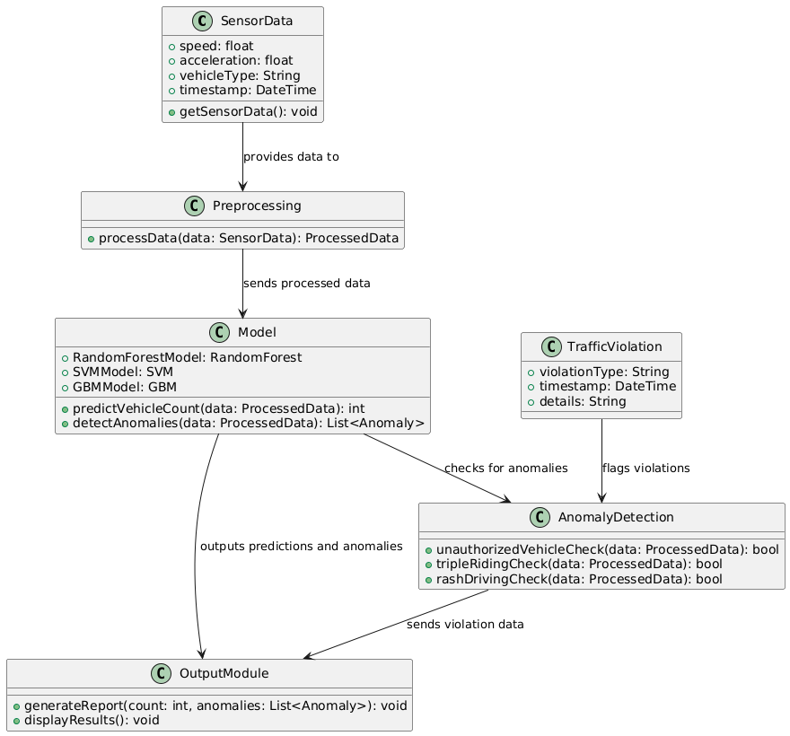

3.2.3 Class Diagram

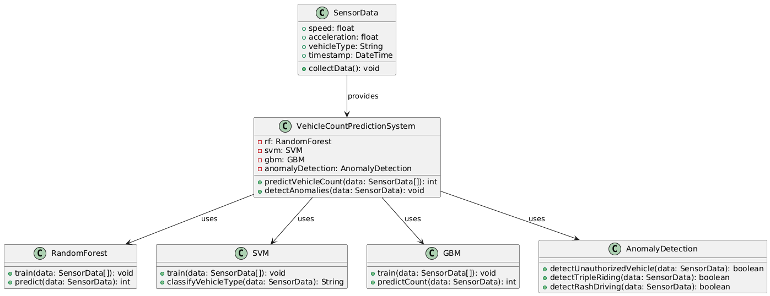

Vehicle Count System: Central controller managing sensor data, prediction, and anomaly detection
Sensor Data: Contains information like speed, acceleration, vehicle type, and
timestamp.
Vehicle Prediction Model: Aggregates multiple models (Random Forest Model,
SVM Model, GBM Model) for training and predictions.
Anomaly Detection: Contains methods to identify unauthorized vehicles, triple
riding, and rash driving.

Sensor: This class represents the various types of sensors used to collect data at road junctions. Each sensor can have attributes such as sensor_id, location, sensor_type (loop detector, infrared sensor, camera), and data (a collection of vehicle counts or timestamps). Methods within this class may include collect_data() to gather real-time sensor readings and filter_data() to clean the data, removing any errors or outliers.

TrafficData: This class stores and organizes the data gathered from the sensors. It contains attributes like sensor_id, timestamp, vehicle_count, junction_id, and time_frame. This class is responsible for storing raw data from each sensor and providing methods such as aggregate_data() to compile the data from multiple sensors at a particular junction or across various junctions.

FeatureEngineer: The FeatureEngineer class handles the creation of new features from the raw sensor data to improve the prediction accuracy. Key attributes might include historical_data, weather_data, time_of_day, day_of_week, etc. It includes methods such as create_time_features() to convert timestamps into meaningful time intervals (e.g., peak or off-peak hours) and merge_external_data() to incorporate additional contextual data like weather or special events.

PredictionModel: This class represents the machine learning model that predicts vehicle counts based on the sensor data and engineered features. It holds the model_type (e.g., linear regression, random forest, neural network), parameters (the model’s hyperparameters), and trained_model (the trained machine learning model object). Methods may include train() to train the model with the given data, evaluate() to assess its performance on the validation dataset, and predict() to make predictions based on incoming sensor data.

    - Use case Diagram

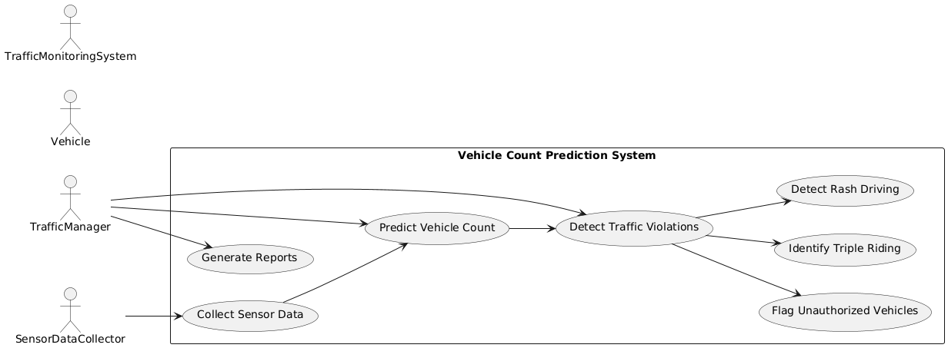

Actors:
- Traffic Sensor Systems: This represents the various sensors deployed at road junctions, such as loop detectors, infrared sensors, and cameras. These systems collect real-time data on the number of vehicles at the junctions.

- Transport Manager: The key user of the system. The Transport Manager monitors traffic conditions, receives vehicle count predictions, and uses these insights to manage traffic flow, optimize routes, and reduce congestion.

- Prediction Model: This actor represents the machine learning model responsible for predicting the vehicle count. The model processes sensor data, analyzes patterns, and generates vehicle count predictions for different time intervals.

- Data Preprocessing System: This system handles the collected raw data, cleaning it, handling missing values, and preparing it for use in the prediction model. It interacts with the traffic sensor systems and prediction model to ensure data integrity.

- Traffic Management System: This system integrates the predictions from the vehicle count prediction model and provides recommendations to the Transport Manager on how to optimize traffic signals, manage congestion, and respond to real-time traffic conditions.

Use Cases:

- Collect Vehicle Data: The Traffic Sensor Systems collect real-time data on vehicle counts at various road junctions. This data includes information on the number of vehicles passing through the sensors at different time intervals.

- Preprocess Data: The Data Preprocessing System cleans and prepares the raw sensor data for use. This includes handling missing data, filtering noise, and formatting the data in a consistent manner that can be ingested by the prediction model.

- Train Predictive Model: The Prediction Model is trained using historical traffic data and other relevant features. This step allows the model to learn patterns and relationships between the sensor data and vehicle counts over time.

- Generate Predictions: Based on the incoming sensor data, the Prediction Model generates vehicle count predictions. These predictions estimate the number of vehicles at different junctions for a specific time frame.

- Evaluate Prediction Accuracy: The Transport Manager or the system evaluates the accuracy of the model’s predictions against actual traffic data. This may involve adjusting the model or incorporating new data to improve prediction quality.

- Monitor Real-time Traffic: The Transport Manager monitors real-time vehicle count predictions. These predictions can be used to inform decisions regarding traffic flow, congestion management, and road network optimization.

- Take Traffic Management Actions: Based on the predicted vehicle counts, the Transport Manager can make real-time decisions about traffic routing, adjusting signal timings, or activating congestion control measures.

- Optimize Prediction Model: The Prediction Model is optimized periodically based on feedback from the actual vehicle counts, ensuring that predictions improve over time as traffic patterns evolve.

- Integrate with Traffic Management System: The predictions generated by the Prediction Model are integrated into the broader Traffic Management System, which uses these insights to support decision-making processes regarding city-wide traffic management.

    - Sequence Diagram

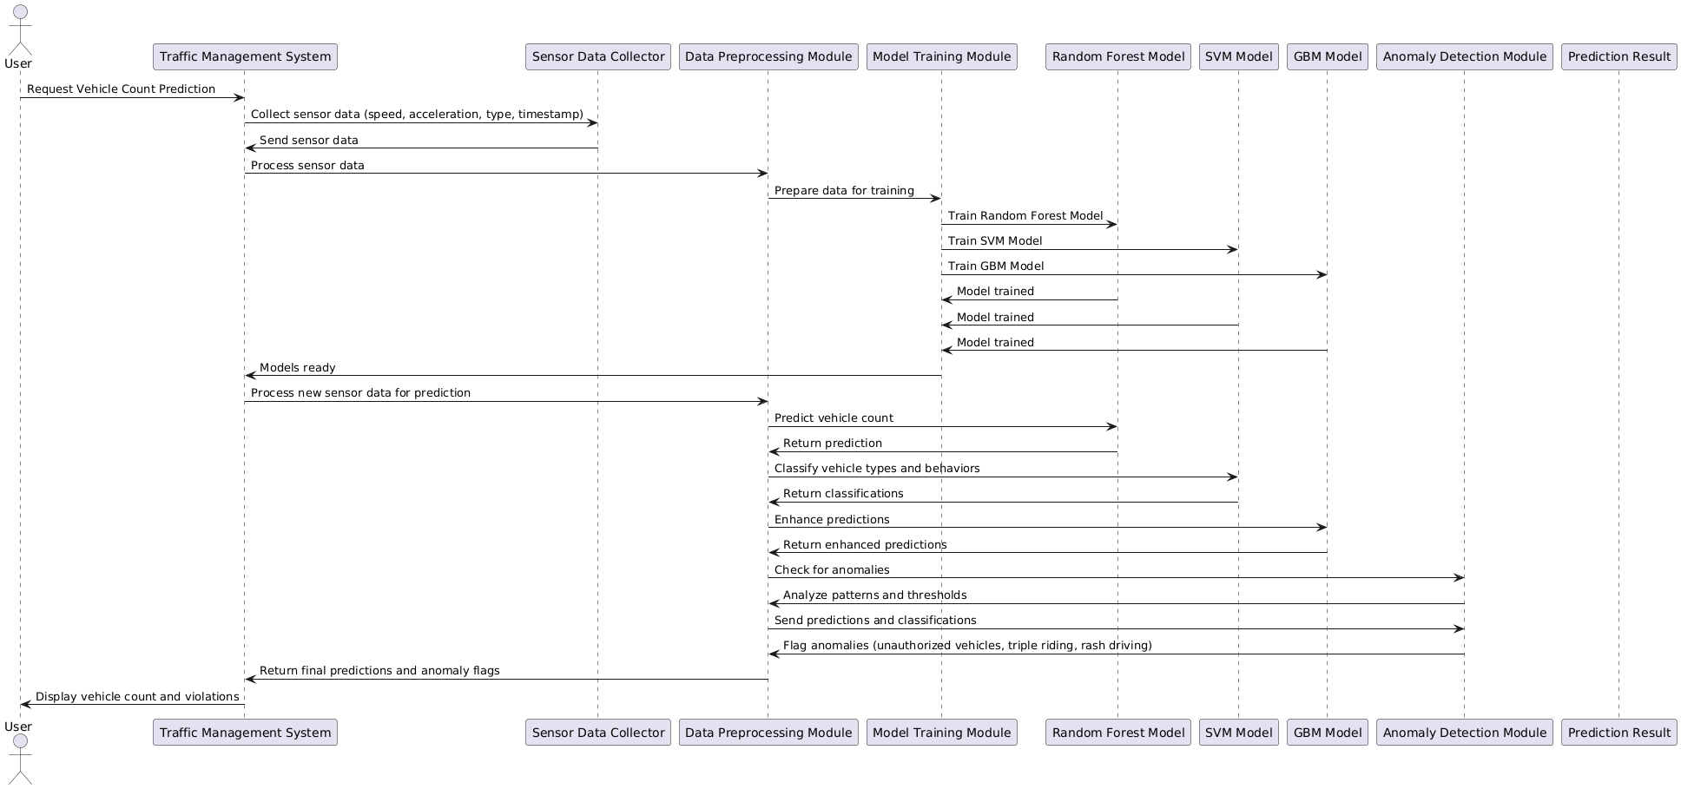

CHAPTER-4

4. Implementation & Testing

4.1 Coding Blocks

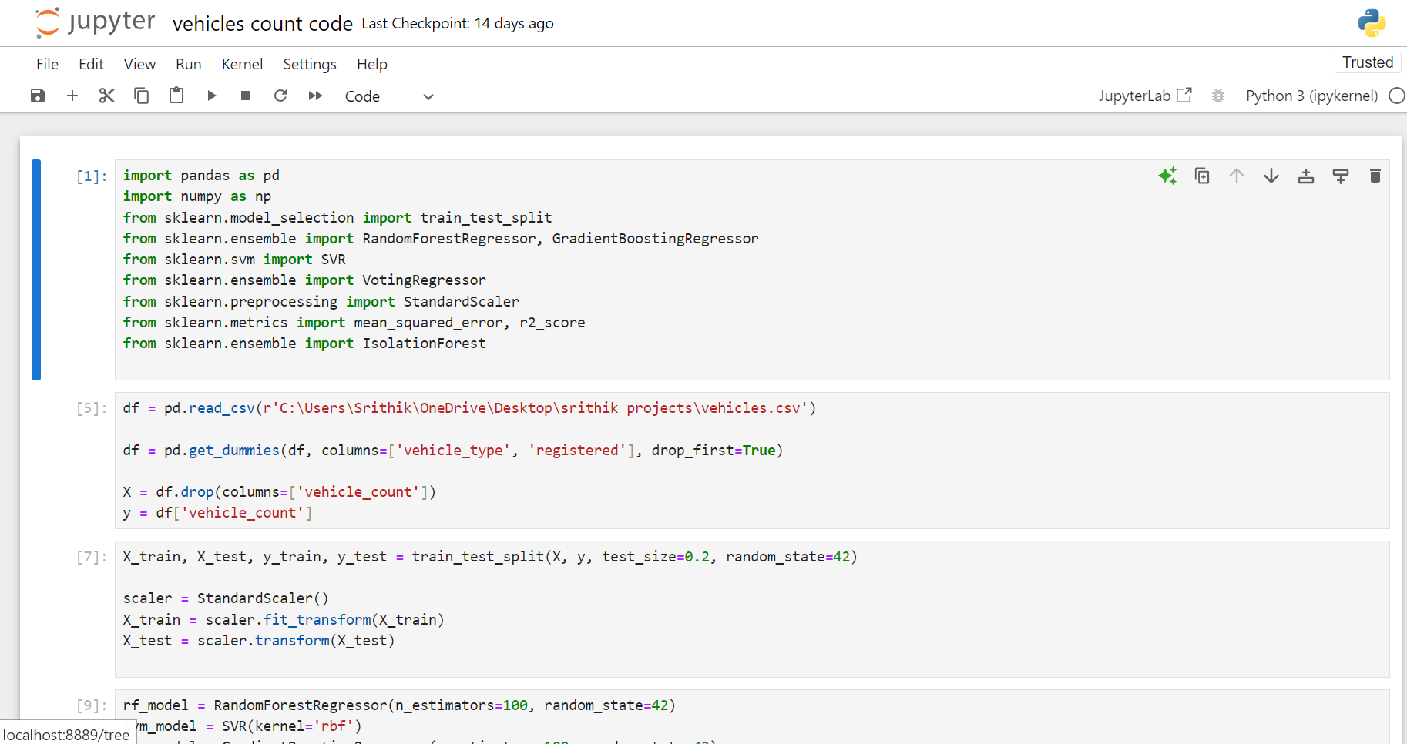

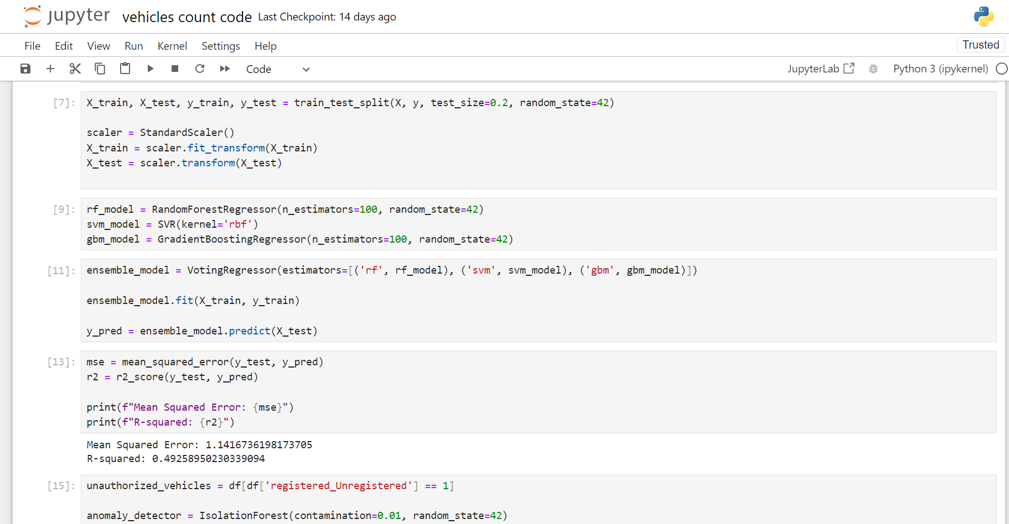

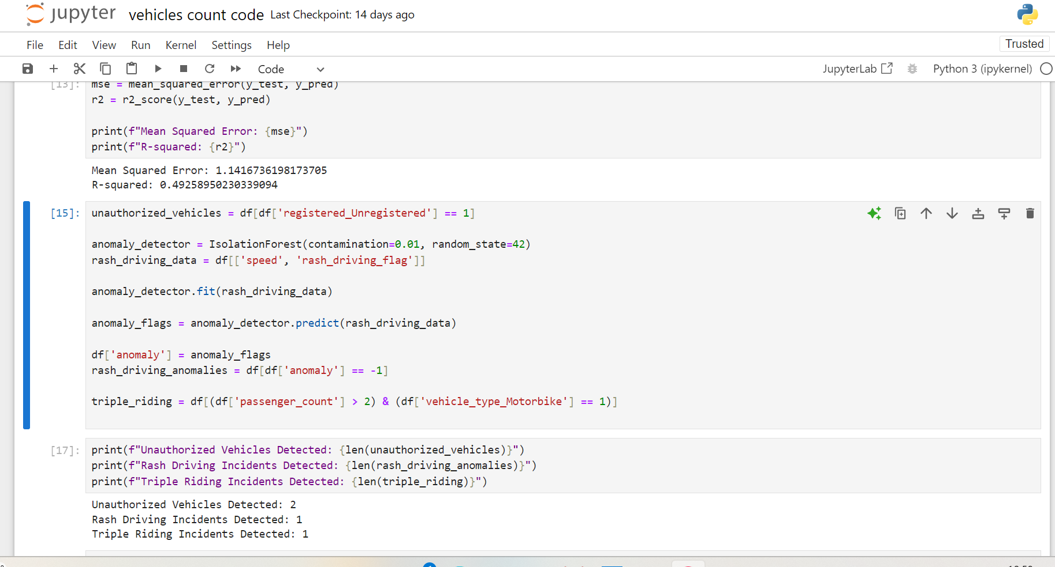

4.2 Sample Code

import pandas as pd
import numpy as np
from sklearn.model_selection import train_test_split
from sklearn.ensemble import RandomForestRegressor, GradientBoostingRegressor
from sklearn.svm import SVR
from sklearn.ensemble import VotingRegressor
from sklearn.preprocessing import StandardScaler
from sklearn.metrics import mean_squared_error, r2_score
from sklearn.ensemble import IsolationForest
df = pd.read_csv(r'C:\Users\Srithik\OneDrive\Desktop\srithik projects\vehicles.csv')

df = pd.get_dummies(df, columns=['vehicle_type', 'registered'], drop_first=True)

X = df.drop(columns=['vehicle_count'])
y = df['vehicle_count']
X_train, X_test, y_train, y_test = train_test_split(X, y, test_size=0.2, random_state=42)

scaler = StandardScaler()
X_train = scaler.fit_transform(X_train)
X_test = scaler.transform(X_test)
rf_model = RandomForestRegressor(n_estimators=100, random_state=42)
svm_model = SVR (kernel='rbf')
gbm_model = Gradient Boosting Regressor (n_estimators=100, random_state=42)
ensemble_model = VotingRegressor(estimators=[('rf', rf_model), ('svm', svm_model), ('gbm', gbm_model)])

ensemble_model.fit(X_train, y_train)

y_pred = ensemble_model.predict(X_test)
mse = mean_squared_error(y_test, y_pred)
r2 = r2_score(y_test, y_pred)

print(f"Mean Squared Error: {mse}")
print(f"R-squared: {r2}")
unauthorized_vehicles = df[df['registered_Unregistered'] == 1]

anomaly_detector = IsolationForest(contamination=0.01, random_state=42)
rash_driving_data = df[['speed', 'rash_driving_flag']]

anomaly_detector.fit(rash_driving_data)

anomaly_flags = anomaly_detector.predict(rash_driving_data)

df['anomaly'] = anomaly_flags
rash_driving_anomalies = df[df['anomaly'] == -1]

triple_riding = df[(df['passenger_count'] > 2) & (df['vehicle_type_Motorbike'] == 1)]
print(f"Unauthorized Vehicles Detected: {len(unauthorized_vehicles)}")
print(f"Rash Driving Incidents Detected: {len(rash_driving_anomalies)}")
print(f"Triple Riding Incidents Detected: {len(triple_riding)}")
4.3 Execution Flow

- Data Collection: Deploy sensors, such as loop detectors, infrared sensors, and cameras, at key road junctions to capture real-time vehicle data. Each sensor collects data on the number of vehicles passing through or present at its respective junction over a specified time interval.

- Data Preprocessing: Clean the raw data collected from different sensors to handle missing values, remove outliers, and standardize formats. This may involve converting data into a consistent unit or encoding sensor-specific data, like timestamps, into time intervals.

- Data Aggregation: Aggregate data from different sensors across multiple junctions. This step ensures that vehicle counts from all sensors are compiled into a single dataset, segmented by location, time, and date.

- Feature Engineering: Identify and create meaningful features for prediction, such as average vehicle counts at specific times of day, day-of-week indicators, weather data, or historical traffic patterns. These features can improve the accuracy of the predictive model by adding context to the raw data.

- Data Splitting: Divide the data into training, validation, and test sets. Typically, a large portion is used for training, with smaller subsets reserved to validate the model and evaluate its performance.

- Model Selection: Choose a suitable machine learning algorithm based on the problem and data characteristics. Common choices for time-series or regression tasks include linear regression, decision trees, random forests, or neural networks.

- Model Training: Train the selected model using the training dataset. The model learns patterns between features and vehicle counts at different junctions, aiming to minimize the error between predicted and actual values.

- Model Evaluation: Evaluate the model's accuracy and performance using the validation dataset. Metrics like Mean Absolute Error (MAE), Mean Squared Error (MSE), or Root Mean Squared Error (RMSE) can assess how close the predictions are to actual vehicle counts.

- Model Optimization: Fine-tune model parameters (hyperparameters) based on the evaluation results to improve accuracy. Techniques like grid search or random search may be used to find optimal parameter settings.

- Prediction: Use the optimized model to predict the vehicle count for specified time frames at various junctions based on incoming sensor data. Predictions can be generated in real time or in batch mode, depending on traffic management needs.

- Results Aggregation: Aggregate the predictions across junctions to get a total vehicle count estimate for a city or larger area. This total can help transport managers assess overall traffic volume and congestion levels.

- Real-time Monitoring: Implement a system for real-time data input, where live sensor data flows into the model, updating predictions as new data is available.

- Feedback Loop: Set up a feedback loop to periodically compare predictions with actual vehicle counts, adjusting the model as needed to improve long-term accuracy. The model can be retrained periodically with new data to account for changing traffic patterns.

- Deployment: Integrate the predictive model into the traffic management system for continuous operation, enabling transport managers to make informed decisions on traffic routing, signal timing, or congestion control based on predicted traffic volumes.



4.4 Testing

- Define Test Scenarios: Identify key scenarios for testing vehicle count prediction, including common traffic conditions (e.g., rush hour, low-traffic periods), unusual events (e.g., road closures, accidents), and seasonal variations (e.g., holiday traffic). Ensure a range of test cases to validate the model's robustness.

- Data Partitioning: Divide the collected data into training, validation, and test sets if not already done. Ensure that the test set covers different times of day, weather conditions, and event-based variations to mirror real-world scenarios.

- Baseline Comparison: Set up a baseline model, such as a simple moving average or linear regression, to provide a comparison for the performance of the predictive model. This helps gauge the improvement offered by the selected model.

- Testing with Historical Data: Run the predictive model on historical test data that was not used in training. This step tests the model's ability to generalize and accurately predict vehicle counts on unseen data.



- Evaluate Seasonal and Temporal Patterns: Compare predictions for specific days of the week, peak hours, and seasons to validate the model's understanding of temporal traffic patterns.

- Sensitivity Analysis: Test the model’s sensitivity to changes in input data, such as slight variations in vehicle counts, different sensor types, or new data from additional junctions. This helps identify the robustness of the model to sensor variability.

- Validation Against Known Events: Check prediction accuracy around known traffic events, like major public gatherings or holidays, to ensure the model can adapt to and handle exceptional traffic conditions.

- Integration Testing: Ensure smooth integration with the larger traffic management system, including compatibility with data formats, real-time data flow, and user interface for transport managers to view predictions and updates.

- Performance Monitoring and Logging: Track the model’s predictions in a live environment, logging predictions, errors, and any anomalies. This monitoring allows continuous assessment and quick issue detection.



- User Feedback Testing: Collect feedback from transport managers and end-users to assess if the predictions align with their expectations and decision-making needs, helping refine the model for practical application.

- Long-term Validation: Periodically re-evaluate the model with new data to assess its predictive accuracy over time and retrain it if necessary to adjust to new traffic patterns or sensor upgrades.

CHAPTER-5

RESULTS



CHAPTER-6

5. Conclusions & Future Scope

Using sensor data for vehicle count prediction proves highly effective, as it enables real-time monitoring and analysis with precision. By leveraging data from sensors like inductive loops, radar, or cameras, predictive models can identify vehicle counts accurately, facilitating better traffic management and flow optimization. Machine learning algorithms enhance these predictions by analyzing patterns, adapting to varied traffic conditions, and improving accuracy over time. This approach supports urban planning, reduces congestion, and can lead to more efficient road usage and safety improvements.

The vehicle count prediction model based on sensor data is a crucial tool for effective traffic management, urban planning, and congestion control. The study demonstrates that leveraging various types of traffic sensors—such as loop detectors, infrared sensors, and cameras—can provide valuable real-time data that, when processed and analyzed correctly, offers accurate predictions of vehicle volumes. Machine learning techniques have proven to be effective in capturing complex patterns and relationships in the data, which may not be immediately apparent through traditional methods.

REFERENCES

[1]Zhang, Y., & Wang, Y. (2018). "Vehicle Count Prediction Using Traffic Flow Data: A Machine Learning Approach." Journal of Transportation Engineering, 144(10), 04018065.

[2]Bhatia, M. P., & Mital, K. (2016). "Application of Machine Learning in Traffic Prediction: A Review." International Journal of Engineering Research and Technology, 5(4), 12-18.

[3]Kumar, A., & Rathi, A. (2020). "Traffic Prediction Using Machine Learning Algorithms: A Comparative Study." International Journal of Computer Applications, 975, 8887.

[4]Lee, S. J., & Lee, J. H. (2019). "Traffic Flow Prediction Using SVM and Random Forest." Journal of Advanced Transportation, 2019, Article ID 6168415.

[5]Zhou, H., & Zhang, H. (2019). "A Hybrid Model for Real-Time Traffic Prediction." IEEE Access, 7, 122342-122355.

[6]Cui, H., & Zhang, L. (2017). "Traffic Violation Detection Based on SVM." International Journal of Traffic and Transportation Engineering, 6(2), 89-95.

[7]. Park, Yong Tae, Pranesh Sthapit, and Jae-Young Pyun. "Smart digital
door lock for the home automation." In TENCON 2009-2009 IEEE
Region 10 Conference, pp. 1-6. IEEE, 2009.

[8]. Park, Yong Tae, Pranesh Sthapit, and Jae-Young Pyun. "Smart digital
door lock for the home automation." In TENCON 2009-2009 IEEE
Region 10 Conference, pp. 1-6. IEEE, 2009.

[9]. Park, Yong Tae, Pranesh Sthapit, and Jae-Young Pyun. "Smart digital
door lock for the home automation." In TENCON 2009-2009 IEEE
Region 10 Conference, pp. 1-6. IEEE, 2009.

[10]. Park, Yong Tae, Pranesh Sthapit, and Jae-Young Pyun. "Smart digital
door lock for the home automation." In TENCON 2009-2009 IEEE
Region 10 Conference, pp. 1-6. IEEE, 2009.

[7]Raza, S. A., & Alomar, N. (2020). "A Comparative Study of Machine Learning Algorithms for Traffic Prediction." Journal of Traffic and Transportation Engineering, 8(4), 12-20.

Kassem, Abdallah, Sami El Murr, Georges Jamous, Elie Saad, and
Marybelle Geagea. "A smart lock system using Wi-Fi security."
In Advances in Computational Tools for Engineering Applications
(ACTEA), 2016 3rd International ConfAdvances in Computational Tools for
Vehicle Count Prediction From Sensor Data

Dr. Mr. M. Ravi kumar
Computer Science & Engineering
Cyber Security &IoT
Malla Reddy University, Hyderabad,

M. Srithik
CSE(IOT)
Malla Reddy University, Hyderabad,
2211cs050064@mallareddyuniversity.ac.in

Abstract-Accurate vehicle count prediction is a critical task in traffic management systems, aiding in congestion control, urban planning, and enhancing road safety. This project focuses on developing a machine learning-based solution for vehicle count prediction using sensor data. The proposed model utilizes a combination of Random Forest, Support Vector Machines (SVM), and Gradient Boosting Machines (GBM) to process sensor data collected from highways, streets, and intersections. The system is designed not only to predict vehicle count but also to detect traffic violations such as unauthorized vehicles, triple riding, and rash driving.
The sensor data, which includes speed, acceleration, vehicle type, and timestamp information, is processed to identify patterns and anomalies that contribute to accurate vehicle count prediction. The Random Forest algorithm is used for its robustness in handling complex datasets, SVM provides high accuracy in distinguishing between vehicle types and driving behaviors, and GBM enhances prediction by minimizing error rates iterative

I.INTRODUCTION

Vehicle count prediction involves forecasting the number of vehicles that will pass through a specific point or region over a given time period. This prediction is based on data collected from sensors, such as inductive loops, cameras, radar, or other traffic monitoring technologies. The primary goal is to create an accurate model that can predict vehicle counts, which is crucial for traffic management, urban planning, and infrastructure optimization.
Vehicle Count Prediction involves estimating the number of vehicles passing through a specific location, such as a road junction or a traffic sensor
In recent years, machine learning techniques have been applied to improve vehicle count prediction from sensor data
Accurate predictions are critical for managing traffic flow, planning infrastructure, and reducing congestion.
Embedded in the road surface, they detect the presence of vehicles by measuring changes in inductance caused by metal vehicles. Vehicle count, speed, and possibly vehicle length.
Vehicle Count Prediction refers to estimating the number of vehicles passing through a specific road segment or intersection during a given time period. This is critical for various applications such as adaptive traffic signal control, road maintenance planning, and the design of intelligent transportation systems (ITS). Traditional traffic management relied on manual counting or infrastructure-intensive solutions such as cameras and road sensors, which may have limitations in accuracy, cost, and scalability.
The increasing urbanization and growth of vehicle traffic present significant challenges for traffic management and urban planning.
With advancements in sensor technology and data analytics, sensor-based vehicle counting has emerged as a reliable and cost-effective solution. Sensors like inductive loop detectors, infrared sensors, acoustic sensors, and radar are commonly used to collect real-time traffic data, providing crucial information about the number of vehicles, their speeds, and flow patterns.
This document explores various sensor types, data preprocessing methods, and predictive models used for vehicle count prediction, as well as the potential applications and benefits of such systems in smart cities and intelligent transportation networks.
To harness this data, machine learning and statistical models can be developed for vehicle count prediction. These models analyze historical traffic data and current sensor data to predict future vehicle counts under varying conditions, such as weather, time of day, and special events. The integration of sensor data with predictive analytics enables more proactive traffic management, allowing authorities to anticipate traffic surges, optimize signal timings, and plan for infrastructure development.

II.LITERATURE SURVEY

[1]The prediction of vehicle counts using sensor data has been extensively researched in the field of Intelligent Transportation Systems (ITS). Various sensor technologies have been explored to collect real-time traffic data, each with its advantages and limitations. Inductive loop detectors (ILDs), one of the earliest and most widely used technologies, work by detecting disturbances in the magnetic field caused by passing vehicles. Studies, such as those by Cheung et al. (2005), have demonstrated their reliability in estimating vehicle count, speed, and classification. However, their installation is invasive, requiring roadwork, and they incur high maintenance costs.

[2]In addition to ILDs, infrared sensors have gained popularity due to their ability to detect vehicles by measuring heat signatures. These sensors perform well in low-visibility conditions, making them suitable for night-time or foggy environments. Research by Deng et al. (2017) highlighted their effectiveness, although extreme weather conditions, such as heavy rain, can affect their performance. Acoustic sensors, which rely on the sound waves generated by passing vehicles, offer a non-invasive alternative.

[3]In recent years, machine learning techniques have been applied to improve vehicle count prediction from sensor data. Models such as Support Vector Machines (SVMs), Artificial Neural Networks (ANNs), and Long Short-Term Memory (LSTM) networks have shown promise in analyzing historical sensor data to predict future traffic flows. For example, Zhang et al. (2018) used LSTM models to capture the temporal dependencies in traffic patterns, demonstrating improved prediction accuracy compared to traditional statistical models.

III.SYSTEM ANALYSIS

EXISTING SYSTEM

The existing systems for vehicle count prediction from sensor data primarily rely on a variety of sensors and statistical or machine learning models to monitor and forecast traffic flow. Inductive Loop Detectors (ILDs) are the most widely implemented technology in many cities, where loops embedded in the pavement detect the presence of vehicles and provide real-time vehicle count data. These systems, although accurate, require costly installation and maintenance due to the physical infrastructure involved. Other sensor types, such as infrared sensors and acoustic sensors, are also in use. Infrared sensors detect vehicles based on their heat signatures, while acoustic sensors capture the sound waves generated by moving vehicles. Both provide real-time data but can be sensitive to environmental conditions such as fog, rain, or external noise.
In terms of prediction models, traditional systems often rely on basic statistical methods such as linear regression or historical average models to forecast vehicle counts. However, these approaches are limited in handling the dynamic and nonlinear nature of traffic flow. Recent systems have integrated machine learning techniques, including Support Vector Machines (SVMs), Artificial Neural Networks (ANNs), and Long Short-Term Memory (LSTM) networks, to improve prediction accuracy. These models leverage historical data along with real-time sensor inputs to capture traffic trends and anticipate vehicle counts more effectively. Some systems also incorporate external factors like weather conditions, time of day, and road events to further enhance predictions. Despite these advancements, existing systems still face challenges in handling the diverse data sources and rapidly changing traffic conditions in urban environments, indicating the need for more adaptive and scalable solutions.

PROPOSED SYSTEM

The proposed system for vehicle count prediction from sensor data aims to address the limitations of existing systems by leveraging a combination of advanced sensors and state-of-the-art machine learning models for more accurate, real-time traffic predictions. Unlike traditional systems that primarily rely on Inductive Loop Detectors (ILDs) or basic sensors, the proposed system integrates a broader range of sensors, including radar, LIDAR, and camera-based sensors, alongside existing infrared and acoustic sensors. This multi-sensor approach ensures greater reliability and accuracy, even in adverse weather conditions or high-noise environments. By fusing data from different sensor types, the system can mitigate the weaknesses of any single sensor, providing a more comprehensive and resilient traffic monitoring solution.
Advantages
- Improved Traffic Management: Real-time vehicle count predictions allow traffic authorities to manage road networks more efficiently.
- Reduction in Traffic Congestion: Accurate predictions help optimize traffic signal timings and reroute vehicles, reducing bottlenecks and minimizing congestion.
- Enhanced Road Safety: Predicting vehicle counts can lead to better traffic control measures, such as adjusting speed limits or restricting access during peak hours.

IV. METHODOLOGY

ARCHITECTURE

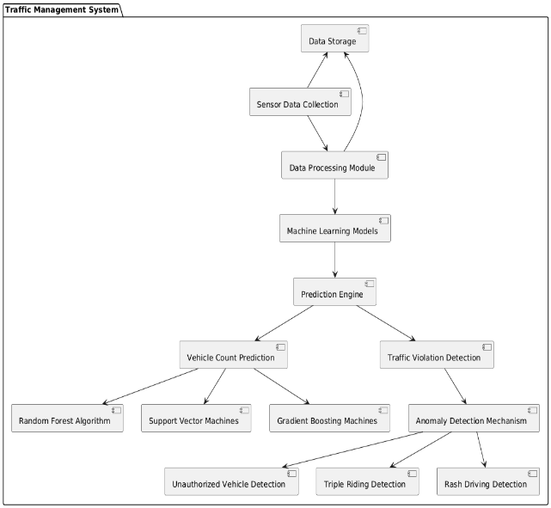

Algorithms Implemented: Fingerprint Verification, String Comparison, Facial Recognition

Fingerprint Verification Algorithm:
A Fingerprint Verification Algorithm on vehicle count prediction by sensor data could work by utilizing unique "fingerprints" derived from various sensor data patterns. In this context, the "fingerprint" of a vehicle is a composite feature vector derived from the fusion of data from multiple sensors such as inductive loop detectors, infrared, acoustic, radar, and camera sensors. This feature vector is then compared against known patterns to verify and predict the count of vehicles with higher accuracy.

String Comparison Algorithm:
A String Comparison Algorithm for vehicle count prediction using sensor data would involve treating the sensor data patterns as strings or sequences of values, and using string matching techniques to compare current patterns with known vehicle signatures. Each sensor would provide a sequence of values (such as signal strength, time intervals, or other measurements), and these sequences can be compared using techniques similar to those used in string matching.

Facial Recognition Algorithm:
Implementing a Facial Recognition Algorithm for vehicle count prediction using sensor data is an innovative approach that combines facial recognition technology with traffic monitoring systems. This method could help in identifying vehicle occupants, enhancing security, and analyzing vehicle types based on driver profiles.

Module 1: User Interface Module
- The User Interface Module in a vehicle count prediction system is a critical component designed to provide users with intuitive and actionable insights derived from sensor data..
- This module features a dashboard that visually presents real-time vehicle counts, categorized by vehicle type, and highlights any detected traffic violations or anomalies, such as unauthorized vehicles or erratic driving behaviors
Module 2: Access Controller Module

- The Access Controller Module in a vehicle count prediction system serves as a vital security and management layer, ensuring that only authorized personnel can access sensitive data and functionalities.
- This module is responsible for user authentication and authorization, allowing different levels of access based on user roles, such as administrators, traffic analysts, or law enforcement officers.
Module 3: Security System Module

- The Security System Module in a vehicle count prediction system is essential for ensuring the safety and integrity of the data collected and processed from various sensors.
- This module is responsible for implementing robust security measures to protect against unauthorized access and potential tampering
Module 4: Authentication Module
- Authenticate users accessing the vehicle count data to prevent unauthorized access.
- This system ensures that only authorized users or devices can interact with the vehicle count data or sensor processing algorithms.
Module 5: Access Control Module
- The Access Control Module for vehicle count prediction leverages sensor data to manage and monitor traffic flow in controlled environments like parking lots, toll gates, or restricted areas.
- By collecting real-time data from sensors—such as infrared, ultrasonic, or radar sensors—this module accurately predicts and monitors the number of vehicles entering or exiting an area.

Module 6: Logging & Notification Module

- The Logging & Notification Module is designed to monitor and record vehicle count predictions derived from sensor data in real-time.
- This module continuously logs data, capturing timestamped predictions, sensor readings, and any anomalies detected, ensuring data integrity and traceability

V. RESULTS

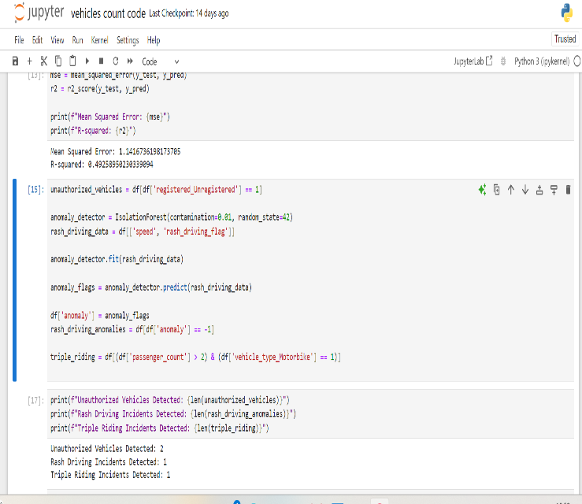

VI. CONCLUSION

Using sensor data for vehicle count prediction proves highly effective, as it enables real-time monitoring and analysis with precision. By leveraging data from sensors like inductive loops, radar, or cameras, predictive models can identify vehicle counts accurately, facilitating better traffic management and flow optimization. Machine learning algorithms enhance these predictions by analyzing patterns, adapting to varied traffic conditions, and improving accuracy over time. This approach supports urban planning, reduces congestion, and can lead to more efficient road usage and safety improvements.

VII. FUTURE WORK

Future work on vehicle count prediction from sensor data could explore more advanced deep learning models, such as transformers or spatiotemporal networks, to better capture complex traffic patterns. Integrating diverse data sources, like weather, calendar events, or road construction schedules, may improve prediction accuracy by accounting for factors that influence traffic flow. Research could also focus on optimizing sensor placement and sensor fusion techniques to reduce prediction errors in regions with sparse data. Additionally, transferring models between different locations or cities might enhance scalability, allowing models trained in one area to adapt effectively to new environments.

REFERENCES

[1]Zhang, Y., & Wang, Y. (2018). "Vehicle Count Prediction Using Traffic Flow Data: A Machine Learning Approach." Journal of Transportation Engineering, 144(10), 04018065.

[2]Bhatia, M. P., & Mital, K. (2016). "Application of Machine Learning in Traffic Prediction: A Review." International Journal of Engineering Research and Technology, 5(4), 12-18.

[3]Kumar, A., & Rathi, A. (2020). "Traffic Prediction Using Machine Learning Algorithms: A Comparative Study." International Journal of Computer Applications, 975, 8887.

[4]Lee, S. J., & Lee, J. H. (2019). "Traffic Flow Prediction Using SVM and Random Forest." Journal of Advanced Transportation, 2019, Article ID 6168415.

[5]Zhou, H., & Zhang, H. (2019). "A Hybrid Model for Real-Time Traffic Prediction." IEEE Access, 7, 122342-122355.

[6]Cui, H., & Zhang, L. (2017). "Traffic Violation Detection Based on SVM." International Journal of Traffic and Transportation Engineering, 6(2), 89-95.

[7]. Park, Yong Tae, Pranesh Sthapit, and Jae-Young Pyun. "Smart digital
door lock for the home automation." In TENCON 2009-2009 IEEE
Region 10 Conference, pp. 1-6. IEEE, 2009.
[7]. Park, Yong Tae, Pranesh Sthapit, and Jae-Young Pyun. "Smart digital
door lock for the home automation." In TENCON 2009-2009 IEEE
Region 10 Conference, pp. 1-6. IEEE, 2009.
[7]. Park, Yong Tae, Pranesh Sthapit, and Jae-Young Pyun. "Smart digital
door lock for the home automation." In TENCON 2009-2009 IEEE
Region 10 Conference, pp. 1-6. IEEE, 2009.
[7]. Park, Yong Tae, Pranesh Sthapit, and Jae-Young Pyun. "Smart digital
door lock for the home automation." In TENCON 2009-2009 IEEE
Region 10 Conference, pp. 1-6. IEEE, 2009.
[7]Raza, S. A., & Alomar, N. (2020). "A Comparative Study of Machine Learning Algorithms for Traffic Prediction." Journal of Traffic and Transportation Engineering, 8(4), 12-20.
Kassem, Abdallah, Sami El Murr, Georges Jamous, Elie Saad, and
Marybelle Geagea. "A smart lock system using Wi-Fi security."
In Advances in Computational Tools for Engineering Applications
(ACTEA), 2016 3rd International ConfAdvances in Computational Tools for Engineering Applications (ACTEA), 2016 3rd International Conference on, pp. 222-225. IEEE, 20
[8]Wang, X., & Zhao, J. (2020). "Predicting Traffic Flow with Enhanced Gradient Boosting Machines.

Poster
